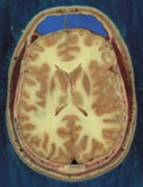

***CSANN* *LAB***

**Deep Neural networks for image/data/video**

**recognition and classification**

**Michigan State University**



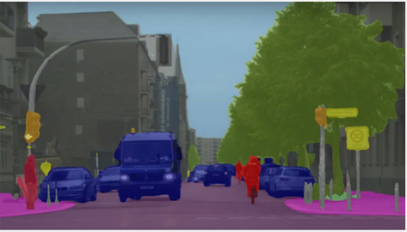

Integration of sensors with quick decision on-the-fly leads to many appealing applications in new generation embedded devices and systems. Example applications are in image/video recognition, identification, tagging, navigations, etc. Simply, such devices would assist the user with instant essential information from staggering images and/or data. Successful and streamlined designs of deep neural networks have demonstrated appealing capabilities, in particular image recognition and classification.

Powerful capabilities can be tailored for the available processing resources or onto embedded low power co-processing FPGAs. This would provide local capabilities for the smart device/phones-- off the cloud-- with added benefits of speedups and device security.

The final project will include demos of the accuracy performance in recognition and classification of the device captured images and/or sounds. The team’s project outcomes will be judged on their ability to satisfy several competing performance metrics: classification and accuracy performance, execution speed and added power consumption expense.

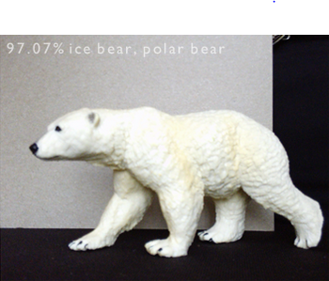

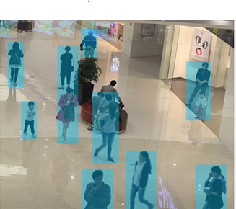

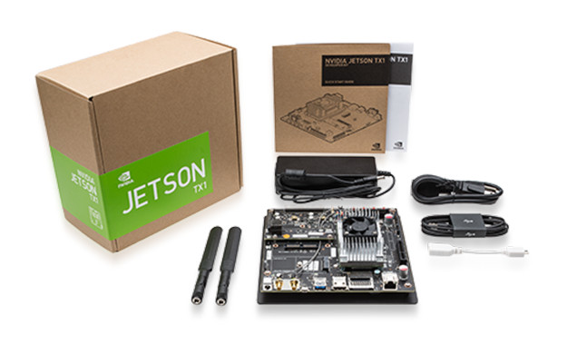

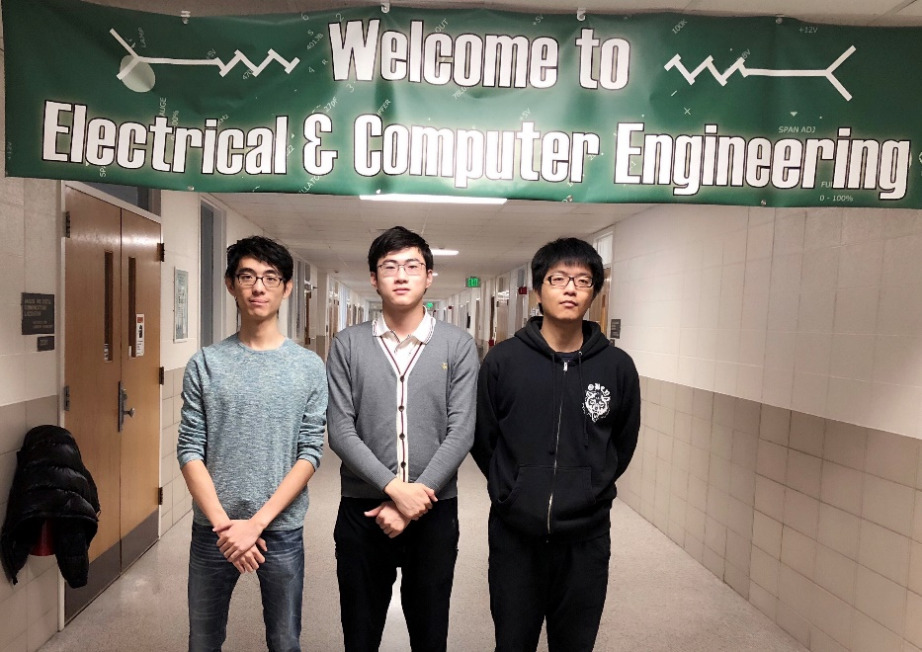

**CASNN**

***Project Sponsor***

The Circuits, Systems, And Neural Networks lab(CSANN)

***MSU Facilitator***

Dr. Fathi Salem

**Michigan State University**

***Team Members***

***(left to right)***

*Jiaxu Zhao*

*Beijing, Beijing, China*

*Shuotao Wang*

*Shaoxing, Zhejiang, China*

*Yu Han*

*Wuhan, Hubei, China*